ASSIGNMENT 1.5(BATCH-29)

2303A51574

Task 1: AI-Generated Logic Without Modularization (String Reversal Without
Functions)
❖ Scenario
You are developing a basic text-processing utility for a messaging
application.
❖ Task Description
Use GitHub Copilot to generate a Python program that:
➢ Reverses a given string
➢ Accepts user input
➢ Implements the logic directly in the main code
➢ Does not use any user-defined functions

CODE:
# Accept user input
user_string = input("Enter a string to reverse: ")
# Reverse the string directly using slicing
reversed_string = user_string[::-1]
# Display the result
print("Original string:", user_string)
print("Reversed string:", reversed_string)

OUTPUT:
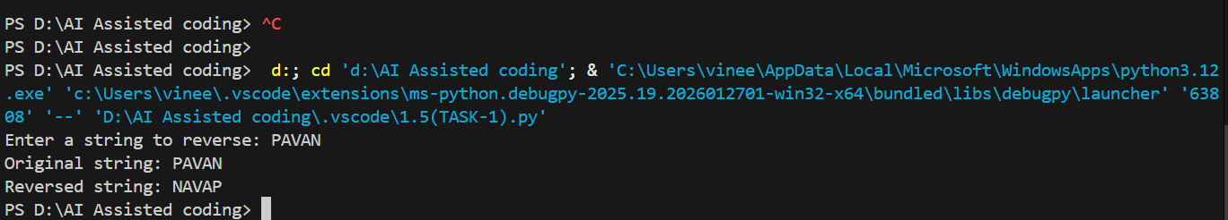

Task 2: Efficiency & Logic Optimization (Readability Improvement)
❖ Scenario
The code will be reviewed by other developers.
❖ Task Description
Examine the Copilot-generated code from Task 1 and improve it by:
➢ Removing unnecessary variables
➢ Simplifying loop or indexing logic
➢ Improving readability
➢ Use Copilot prompts like:
▪ “Simplify this string reversal code”
▪ “Improve readability and efficiency”

CODE:
# ============================================
# String Reversal Program
# ============================================
# Step 1: Accept user input
print("=" * 45)
print("STRING REVERSAL")
print("=" * 45)
user_string = input("\nEnter a string to reverse: ")
# Step 2: Reverse the string using slicing
reversed_string = user_string[::-1]
# Step 3: Display the results
print("\n" + "-" * 45)
print(f"Original string: {user_string}")
print(f"Reversed string: {reversed_string}")
print("-" * 45)

OUTPUT:
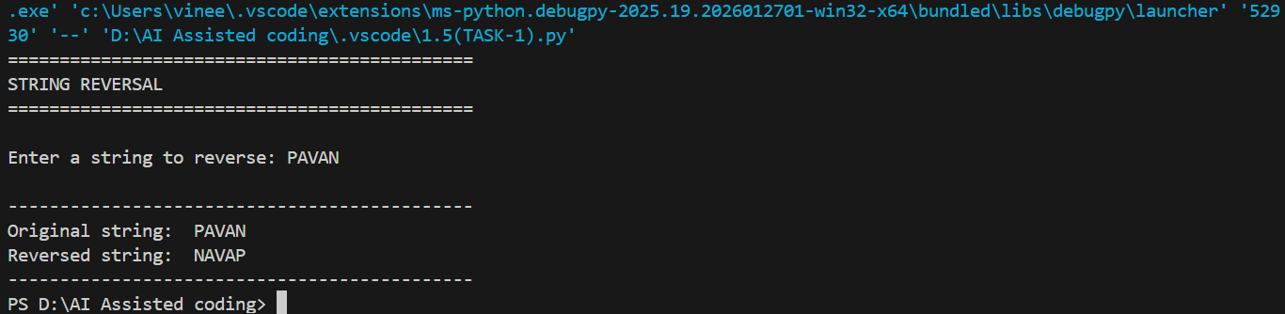
Task 3: Modular Design Using AI Assistance (String Reversal Using Functions)
❖ Scenario
The string reversal logic is needed in multiple parts of an application.
❖ Task Description
Use GitHub Copilot to generate a function-based Python program that:
➢ Uses a user-defined function to reverse a string
➢ Returns the reversed string
➢ Includes meaningful comments (AI-assisted)

CODE:
# ============================================
# String Reversal Program with User-Defined Function
# ============================================
def reverse_string(input_str):
"""
This function reverses a given string using Python's slicing technique.
Parameters:
-----------
input_str (str): The string to be reversed
Returns:
--------
str: The reversed version of the input string
Logic:
------
Uses the slicing operator [::-1] which:
- Starts from the end of the string
- Goes backwards with a step of -1
- Returns the complete reversed string
"""
# Reverse the string using slice notation (start:stop:step)
# [::-1] means: start from end, go to beginning, step backwards by 1
reversed_str = input_str[::-1]
# Return the reversed string to the caller
return reversed_str
# Main Program Execution
# ============================================
# Display program header with visual separators
print("=" * 50)
print("STRING REVERSAL PROGRAM")
print("=" * 50)
# Step 1: Accept input from user
# The input() function prompts the user for a string
user_input = input("\nEnter a string to reverse: ")
# Step 2: Call the reverse_string function
# Pass the user input to the function and store the returned value
reversed_result = reverse_string(user_input)
# Step 3: Display the results
# Show both original and reversed strings with clear formatting
print("\n" + "-" * 50)
print(f"Original string: {user_input}")
print(f"Reversed string: {reversed_result}")
print("-" * 50)

OUTPUT: 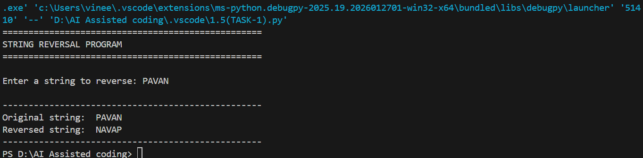
Task 4: Comparative Analysis – Procedural vs Modular Approach (With vs
Without Functions)
❖ Scenario
You are asked to justify design choices during a code review.
❖ Task Description
Compare the Copilot-generated programs:
➢ Without functions (Task 1)
➢ With functions (Task 3)
Analyze them based on:
➢ Code clarity
➢ Reusability
➢ Debugging ease
➢ Suitability for large-scale applications

COMPARISON TABLE
Criteria | Code 1: Without User-Defined Function | Code 2: With User-Defined Function
Code Clarity | Very simple and short. Easy to understand for beginners, but logic and input/output are mixed together. | More structured and well-organized. Logic is separated from input/output, improving readability.
Reusability | Not reusable. The reversal logic is written directly in the main code and cannot be reused without copying. | Highly reusable. The reverse_string() function can be reused in other programs or modules.
Debugging Ease | Easy for small programs, but difficult as the code grows because everything is in one place. | Easier to debug. Errors can be isolated inside the function without affecting the rest of the program.
Suitability for Larger-Scale Applications | Not suitable. Lack of modularity makes the code hard to maintain and scale. | Very suitable. Modular design supports maintenance, testing, and expansion in large applications.
Maintainability | Low maintainability. Any change requires editing the main logic directly. | High maintainability. Changes can be made inside the function without affecting other code.
Readability for Team Projects | Poor for team environments due to lack of structure. | Good for collaborative development due to clear separation of concerns.
Performance | Slightly faster for very small scripts due to no function call overhead (negligible difference). | Slight overhead due to function calls, but insignificant in real applications.
Assignment Compliance (Task 1) | Fully compliant with Task 1 requirements. | Not compliant, because it uses a user-defined function.

Task 5: AI-Generated Iterative vs Recursive Fibonacci Approaches (Different
Algorithmic Approaches to String Reversal)
❖ Scenario
Your mentor wants to evaluate how AI handles alternative logic paths.
❖ Task Description
Prompt GitHub Copilot to generate:
➢ A loop-based string reversal approach
➢ A built-in / slicing-based string reversal approach

CODE:
# ============================================
# String Reversal Program: Two Approaches
# ============================================

# APPROACH 1: LOOP-BASED STRING REVERSAL
# ============================================

def reverse_string_loop(input_str):
"""
This function reverses a string using a loop-based approach.

Parameters:
-----------
input_str (str): The string to be reversed

Returns:
--------
str: The reversed version of the input string

Logic:
------
Iterates through the string from the end to the beginning:
- Initialize an empty result string
- Loop from the last character index to 0
- Concatenate each character to the result
- Return the concatenated reversed string
"""

# Initialize an empty string to store the reversed result
reversed_str = ""

# Loop from the last character index (len-1) down to 0
# range(len(input_str)-1, -1, -1) creates: last_index, ..., 1, 0
for i in range(len(input_str) - 1, -1, -1):
# Append each character starting from the end
reversed_str += input_str[i]

# Return the completely reversed string
return reversed_str

# APPROACH 2: SLICING-BASED STRING REVERSAL (BUILT-IN)
# ============================================

def reverse_string_slicing(input_str):
"""
This function reverses a string using Python's slicing technique.

Parameters:
-----------
input_str (str): The string to be reversed

Returns:
--------
str: The reversed version of the input string

Logic:
------
Uses the slicing operator [::-1] which:
- Starts from the end of the string (default start position)
- Goes to the beginning (default stop position)
- Steps backwards by 1 with the negative step value
- Returns the complete reversed string efficiently
"""

# Reverse the string using slice notation (start:stop:step)
# [::-1] means: start from end, go to beginning, step backwards by 1
# This is the most Pythonic and efficient way to reverse a string
reversed_str = input_str[::-1]

# Return the reversed string to the caller
return reversed_str

# MAIN PROGRAM EXECUTION
# ============================================

# Display program header with visual separators
print("=" * 60)
print("STRING REVERSAL PROGRAM - TWO APPROACHES")
print("=" * 60)

# Step 1: Accept input from user
# The input() function prompts the user to enter a string
user_input = input("\nEnter a string to reverse: ")

# Step 2a: Reverse using LOOP-BASED approach
# Pass the user input to the loop-based function
reversed_loop = reverse_string_loop(user_input)

# Step 2b: Reverse using SLICING-BASED approach
# Pass the user input to the slicing-based function
reversed_slicing = reverse_string_slicing(user_input)

# Step 3: Display the results
# Show original and both reversed versions with clear formatting
print("\n" + "-" * 60)
print(f"Original string: {user_input}")
print(f"Reversed (Loop Method): {reversed_loop}")
print(f"Reversed (Slicing Method): {reversed_slicing}")
print("-" * 60)

OUTPUT:
